Experiment No – 1
Title / Aim :- Demonstrate inline, internal, and external JavaScript; use console methods; create a webpage showing user info and a welcome message.

Software/Tools Required :-
- Visual Studio Code (VS Code)
- Google Chrome / Any Web Browser
- HTML
- JavaScript

Code:-
Index.html
<!DOCTYPE html>
<html lang="en">

<head>
<meta charset="UTF-8">
<meta name="viewport" content="width=device-width, initial-scale=1.0">
<title>JavaScript Experiment 1</title>

<style>
body {
margin: 0;
font-family: Arial, sans-serif;
background-color: #eef5ff;
}

.header {
background-color: #4CAF50;
color: white;
padding: 18px;
text-align: center;
}

.container {
width: 60%;
margin: 30px auto;
background: white;
padding: 20px;
border-radius: 8px;
border: 2px solid #4CAF50;
}

table {
width: 100%;
border-collapse: collapse;
margin-top: 15px;
}

table, th, td {
border: 1px solid gray;
}

th {
background-color: #4CAF50;
color: white;
padding: 10px;
}

td {
padding: 10px;
}

.buttons {
text-align: center;
margin-top: 25px;
}

button {
background-color: #4CAF50;
color: white;
border: none;
padding: 10px 18px;
margin: 8px;
border-radius: 5px;
cursor: pointer;
}

button:hover {
background-color: #388E3C;
}

#message {
text-align: center;
color: darkblue;
font-weight: bold;
margin-top: 15px;
}
</style>

<script>
function showProfile() {

document.getElementById("message").innerHTML =
"Welcome to JavaScript Lab!";

document.getElementById("name").innerHTML =
"Shivangi Kushwaha";

document.getElementById("roll").innerHTML =
"24070521164";

document.getElementById("branch").innerHTML =
"Computer Science and Engineering with AIML Specialization";

document.getElementById("semester").innerHTML =
"5th Semester";

console.log("Profile Displayed");
console.info("Internal JavaScript Executed");

}
</script>

</head>

<body>

<div class="header">
<h1>Student Information Dashboard</h1>
</div>

<div class="container">

<table>

<tr>
<th>Field</th>
<th>Information</th>
</tr>

<tr>
<td>Name</td>
<td id="name">---</td>
</tr>

<tr>
<td>Roll Number</td>
<td id="roll">---</td>
</tr>

<tr>
<td>Branch</td>
<td id="branch">---</td>
</tr>

<tr>
<td>Semester</td>
<td id="semester">---</td>
</tr>

</table>

<p id="message">Click any button below.</p>

<div class="buttons">

<button onclick="alert('Welcome to JavaScript! Shivangi...');">
Inline JS
</button>

<button onclick="showProfile()">
Internal JS
</button>

<button onclick="showConsole()">
External JS
</button>

</div>

</div>

<script src="script.js"></script>

</body>

</html>

Script.js
function showConsole() {

alert("External JavaScript File Executed");

console.log("Console Log");
console.warn("Console Warning");
console.error("Console Error");
console.info("Console Information");

let student = [
{
Name: "Shivangi",
Branch: "AIML",
Semester: "3rd"
}
];

console.table(student);

}

Output

Inline JS

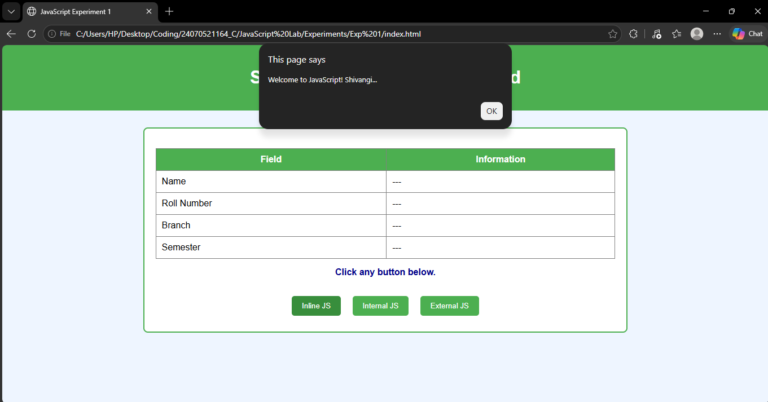

Internal JS
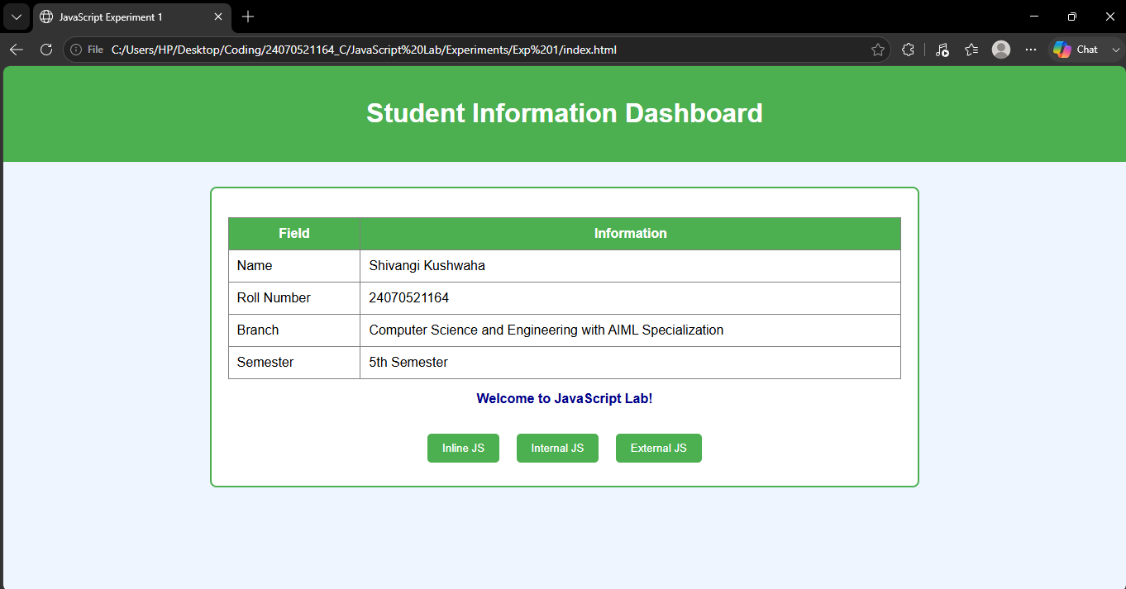

External JS

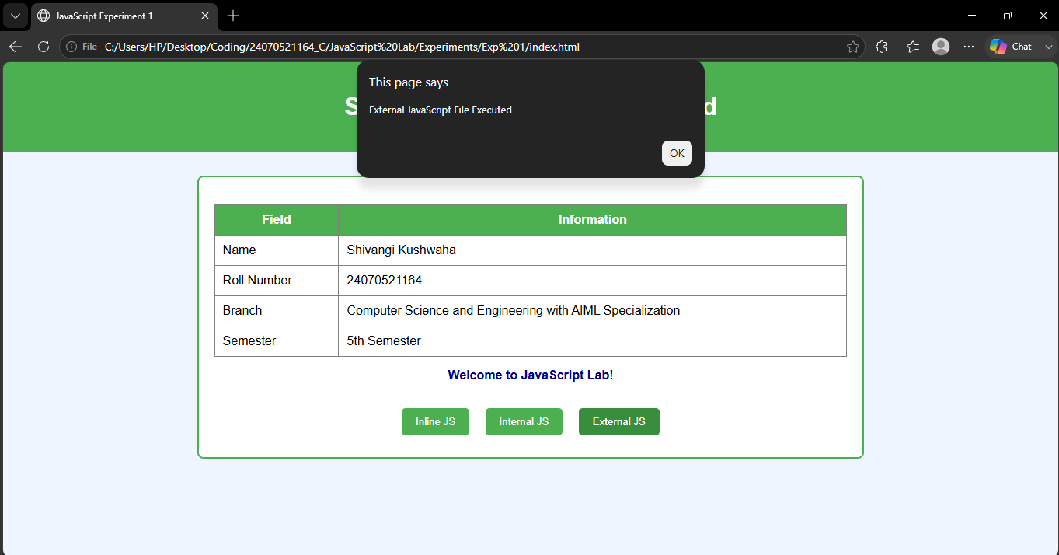

Result / Conclusion :-
The experiment was successfully performed. Different types of JavaScript (Inline, Internal, and External) were implemented successfully. Console methods were used to display debugging messages, and a webpage displaying student information with a welcome message was created successfully.

